The effects of shade on temperature measurements

Karim El-Sharkawy

EAPS 22700 Lab 1

15th September 2021

Introduction:

There were many purposes for doing this lab. First, and most important, is that the lab was designed to get us outside and scope out good places to get data. Finding places to get good data was sometimes sporadic, but it taught me how to have a little bit of patience. Second, I believe this lab was supposed to elucidate our understanding of taking temperature measurements. Taking temperatures in the shade will give us the lowest possible temperature (assuming 100% shade) and taking temperatures in the sunlight with no shade or radiation shield will grant us a much higher temperature. There might just be more purposes/benefits we obtained from this lab that I might've missed!

The two hypotheses we tested (according to our instructions) were:

1. “When the Kestrel thermistor is exposed to the sun, the Kestrel's temperature measurements will be too high (relative to KLAF's readings).”
2. “When the Kestrel thermistor is exposed to the sun and a simple radiation shield is used to block it, the Kestrel's temperature measurements will still be too high (relative to KLAF), but not as high as when the radiation shield is absent.”

Instruments:

We used Kestrel 5400 Heat Stress Trackers to record our temperatures (Nielsen-Kellerman 2021). I specifically used two Kestrels during this lab because my first one lost battery. My first five measurements were taken with a 5400 Kestrel and my last 8 were taken with a Kestrel 4000 (Nielsen-Kellerman Co., 2014: Kestrel 4000 Weather Meter: User Guide). These kestrels have Thermistors which are resistance thermometers. Thermistors, “are made of a temperature-sensitive semiconductor material that is pressed into small beads, chips, or rods,” (UCAR/COMET, 2017: Instrumentation and Measurement of Atmospheric Temperature). According to the manufacturer, The measurements of the Kestrels have an accuracy of 0.9℉ or 0.5C℃(Nielsen-Kellerman Co., 2020: Kestrel 5400 Heat Stress Trackers: Certificate of Conformity. Page 2).

Method**:**

There were 13 measurements taken in total. All of my measurements were close to the Stanley Coulter building. The farthest I went was the Weatherill Hall building. All of the measurements were taken on Wednesday, the 8th of September 2021. My first measurement was taken roughly at 10:07 AM EDT (0207 AM UTC) and my last measurement was taken roughly at 10:30 AM EDT (0230 AM UTC). My procedure was to go to a place I desired to take a measurement (depending on shade), hold the kestrel at eye level, and wait until the temperature stabilized. When taking measurements with the radiation shield, I made sure to take it in the same place that I took my measurements in the sun without the radiation shield. I would take one measurement without the radiation shield, and then put the radiation shield on to record the temperature again. It’s important to note that the thermistor should never be covered or touched when taking measurements. This could affect the temperature readings. I will also provide a link below to a video and photo album of me explaining my procedure and what could be improved.

Video: <https://youtu.be/F8XzSUEp57A>

Photos: <https://photos.app.goo.gl/uEeVxzxssfLnvYUA8>

Data**:**

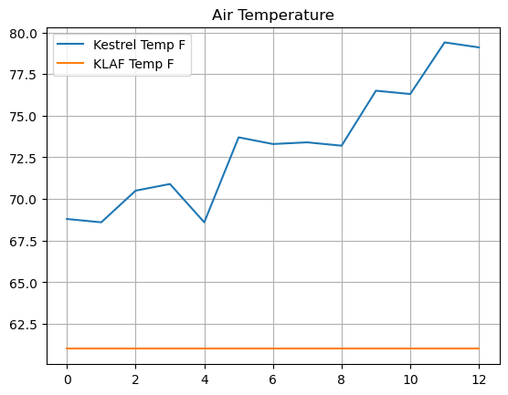

Fig. 1: Air temperature of the KLAF in ℉ compared to the recorded temperature from the Kestrel in ℉.

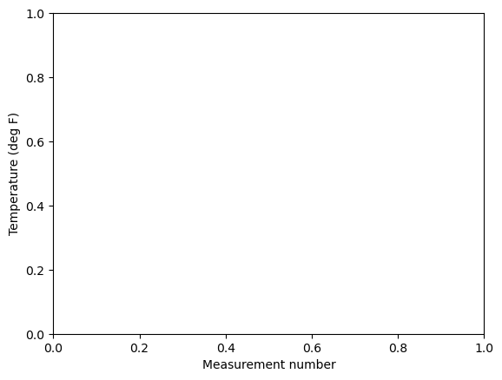

This is the graph I got when I tried plotting “plt.xlabel("Measurement number") plt.ylabel("Temperature (deg F)")”. I don’t know what I’m missing in my code here.

Table 1: Temperature measurements collected

| Measurement number | Shady or sunny | Radiation Shield | Kestrel Temp (F) | KLAF Temp (F) | Kestrel - KLAF |
| --- | --- | --- | --- | --- | --- |
| 0 | Shady | False | 68.8 | 61.0 | 7.8 |
| 1 | Shady | False | 68.6 | 61.0 | 7.6 |
| 2 | Shady | False | 70.5 | 61.0 | 9.5 |
| 3 | Shady | False | 70.9 | 61.0 | 9.9 |
| 4 | Shady | False | 68.6 | 61.0 | 7.6 |
| 5 | Sunny | False | 73.7 | 61.0 | 12.7 |
| 6 | Sunny | True | 73.3 | 61.0 | 12.3 |
| 7 | Sunny | False | 73.4 | 61.0 | 12.4 |
| 8 | Sunny | True | 73.2 | 61.0 | 12.2 |
| 9 | Sunny | False | 76.5 | 61.0 | 15.5 |
| 10 | Sunny | True | 76.3 | 61.0 | 15.3 |
| 11 | Sunny | False | 79.4 | 61.0 | 18.4 |
| 12 | Sunny | True | 79.1 | 61.0 | 18.1 |

Discussion**:**

It’s important to cogitate on the process of gathering data and what the data means.

1. Relative to KLAF’s readings, the temperature recorded on the Kestrel will be too high when exposed to the sun.

As Figure 1 and Table 1 show, the Kestrel measurements are much larger compared to the KLAF temperatures when exposed to the sun. The mean of the Kestrel-KLAF temperature is 159.3/13 = 12.3 ~ 12 degrees. I don’t think this is acceptable at all a difference of 12 degrees can change people’s days significantly. I think most people would reject this.

1. The temperature recorded on the Kestrel when using a radiation shield will be lower than without one, but will still be too high relative to the KLAF temperature.

This is most definitely correct. While it wasn’t by match, the Kestrel-KLAF temperature measurements were lower with the radiation shield than without it. It’s important to note that some had higher temperature values when using the radiation shield. I had a similar issue, but a little different. It increased at first, then decreased after a little bit of time has passed.

Conclusion:

In conclusion, this lab tested the effects of using a radiation shield to record temperatures. If I were to redo this experiment, I would use the same Kestrel to record measurements and would use more time to collect data. However, while my data is flawed, it illustrates the effects of using a radiation shield well.

Bibliography

1. UCAR/COMET, 2017: Instrumentation and Measurement of Atmospheric Temperature. <https://www.meted.ucar.edu/instrumentation/temperature/index.htm> (Accessed 2021).
2. Nielsen-Kellerman Co., 2020: Kestrel 5400 Heat Stress Trackers: Certificate of Conformity. Available from: <https://kestrelinstruments.com/mwdownloads/download/link/id/41/>.
3. Nielsen-Kellerman Co., 2021: Kestrel 5400 Heat Stress Trackers: User Guide. Available from: <https://kestrelinstruments.com/mwdownloads/download/link/id/14/>
4. Nielsen-Kellerman Co., 2014: Kestrel 4000 Weather Meter: User Guide. Available from: <https://cdn.shopify.com/s/files/1/0084/9012/files/318433_4_140306_web.pdf?6509385256888391313>.